MSDS 6371 HW 2
Questions 3a and 3b covered in Live Session. You may use your answers from live session but add them to you HW for completeness. Also, put your answer in your own words (students should not copy and paste the solution given in live session.)

- The world’s smallest mammal is the bumblebee bat, also known as the Kitti’s hog nosed bat. Such bats are roughly the size of a large bumblebee! Listed below are weights (in grams) from a sample of these bats. Test the claim that these bats come from the same population having a mean weight equal to 1.8 g. (Beware: This data is NOT the same as in the lecture slides!)
Sample: 1.7 1.6 1.5 2.0 2.3 1.6 1.6 1.8 1.5 1.7 1.2 1.4 1.6 1.6 1.6

  - Perform a complete analysis using SAS. Use the six step hypothesis test with a conclusion that includes a statistical conclusion, a confidence interval, and a scope of inference (as best as can be done with the information above … there are many correct answers given the vagueness of the description of the sampling mechanism).
    - H_{0:} μ = 1.8g or H_{a} μ ≠ 1.8g
    - α=.05, (.1854,.3993)
    - t statistic: 25.1906
    - P Value: < .0001
    - Reject H₀
    - I am 95% confidence that true mean weight of the Bumblebee Bat does not equal to 1.8 grams. Since the P-Value is extremely low calculated below .0001, the chances of sample mean of 1.6467 grams occurring with the same sample size, is less than one in one thousand. This is why I choose to t reject the null hypothesis that the population mean is equal to 1.8 grams.
  - Inspect and run this R Code and compare the results (t statistic, p-value, and confidence interval) to those you found in SAS. To run the code, simply copy and paste the below code into R. How did I Get such a different answer between R and SAS?!!?
sample = c(1.7, 1.6, 1.5, 2.0, 2.3, 1.6, 1.6, 1.8, 1.5, 1.7, 1.2, 1.4, 1.6, 1.6, 1.6)
t.test(x=sample, mu = 1.8, conf.int = "TRUE", alternative = "two.sided")
Output:
One Sample t-test
data: sample
t = -2.3457, df = 14, p-value = 0.03424
alternative hypothesis: true mean is not equal to 1.8
95 percent confidence interval:
1.506466 1.786868
sample estimates:
mean of x
1.646667

- In the United States, it is illegal to discriminate against people based on various attributes. One example is age. An active lawsuit, filed August 30, 2011, in the Los Angeles District Office is a case against the American Samoa Government for systematic age discrimination by preferentially firing older workers. Though the data and details are currently sealed, suppose that a random sample of the ages of fired and not fired people in the American Samoa Government are listed below:
Fired
34 37 37 38 41 42 43 44 44 45 45 45 46 48 49 53 53 54 54 55 56
Not fired
27 33 36 37 38 38 39 42 42 43 43 44 44 44 45 45 45 45 46 46 47 47 48 48 49 49 51 51 52 54

        - Perform a permutation test to test the claim that there is age discrimination. Provide the Ho and Ha, the p-value, and full statistical conclusion, including the scope (inference on population and causal inference). Note: this was similar to an example in Live Session 1. You may start from scratch or use the sample code and PowerPoints from Live Session 1.
    - Only 273 of 1000 permutations would fit within a 95 % Confidence Level Interval
    - H0:μ1 – μ2 = 0
    - Ha: μ1 – μ2 ≠ 0
    - Pvalue: .2771
    - Given that this is a random sample of fired/not fired employees of the American Samoa Government. We should be able to generalize this sample to a larger population, if we are to assume that the sample was created in a situation where each individual of the American Samoa Government had an equal chance of being in the sample.
    - Conclusively, given this sample, we are unable to determine that the null Hypothesis is false. The P-Value of the study is .257, demonstrating that the probability of achieving a statistic that is more extreme than this value is roughly 26%. This value is not low enough for us to assume that the difference in population means is different than 0.

        - Now run a two sample t-test appropriate for this scientific problem. (Use SAS.) (Note: we may not have talked much about a two-sided versus a one-sided test. If you would like to read the discussion on pg. 44 (Statistical Sleuth), you can run a one-sided test if it seems appropriate. Otherwise, just run a two-sided test as in class. There are also examples in the Statistics Bridge Course.) Be sure to include all six steps, a statistical conclusion, and scope of inference.
    - H0:μ1 – μ2 = 0and Ha: μ1 – μ2 ≠ 0
    - Significance Level: .05
    - Critical Values: (-5.4413, 1.5936)
    - T-Stat: -1.10
    - P-Value: .2771
    - Fail to Reject H0
    - Given the two samples and that the assumption of the null hypothesis is true, we’re 95% confident that difference in sample means would fall within the -5.4413 and 1.5936. This observation does not provide strong enough evidence for us to assume that the difference in mean age of fired and not fired employees are different than 0.
        - Compare this p-value to the randomized p-value found in the previous sub-question.
    - A: .2771 = B: .2771
        - The jury wants to see a range of plausible values for the difference in means between the fired and not fired groups. Provide them with a confidence interval for the difference of means and an interpretation.
    - See Appendix a.
        - Given the sample standard deviations from SAS, calculate by hand
          - Pooled standard deviation (s_{p})
          - The standard error of (${\overline{X}}_{FIRED}-{\overline{X}}_{Not Fired}$)
        - See Appendix b.
        - Inspect and run this R Code and compare the results (t statistic, p-value, and confidence interval) to those you found in SAS. To run the code, simply copy and paste the code below into R.
Fired = c(34, 37, 37, 38, 41, 42, 43, 44, 44, 45, 45, 45, 46, 48, 49, 53, 53, 54, 54, 55, 56)
Not_fired = c(27, 33, 36, 37, 38, 38, 39, 42, 42, 43, 43, 44, 44, 44, 45, 45, 45, 45, 46, 46, 47, 47, 48, 48, 49, 49, 51, 51, 52, 54)
t.test(x = Fired, y = Not_fired, conf.int = .95, var.equal = TRUE, alternative = "two.sided")
Two Sample t-test

data: Fired and Not_fired
t = 1.0991, df = 49, p-value = 0.2771
alternative hypothesis: true difference in means is not equal to 0
95 percent confidence interval:
-1.593635 5.441254
sample estimates:
mean of x mean of y
45.85714 43.93333

- In the last homework, it was mentioned that a Business Stats professor here at SMU polled his class and asked students them how much money (cash) they had in their pockets at that very moment. The idea was that we wanted to see if there was evidence that those in charge of the vending machines should include the expensive bill / coin acceptor or if it should just have the credit card reader. However, another professor from Seattle University was asked to poll her class with the same question. Below are the results of the polls.
SMU
34, 1200, 23, 50, 60, 50, 0, 0, 30, 89, 0, 300, 400, 20, 10, 0
Seattle U
20, 10, 5, 0, 30, 50, 0, 100, 110, 0, 40, 10, 3, 0

        - Run a two sample t-test to test if the mean amount of pocket cash from students at SMU is different than that of students from Seattle University. Write up a complete analysis: all 6 steps including a statistical conclusion and scope of inference (similar to the one from the PowerPoint). (This should include identifying the Ho and Ha as well as the p-value.) Also include the appropriate confidence interval. FUTURE DATA SCIENTIST’S CHOICE!: YOU MAY USE SAS OR R TO DO THIS PROBLEM!
- H_{0:} μ_{SMU} - μ_{Seattle} = $0 or H_{a} : μ_{SMU} - μ_{Seattle} ≠ $0
- α=.05, (-52.57286, 306.57286)
- t statistic: 1.4537
- P Value: .158
- Fail to Reject H₀
- If we had to make a conclusion based only on the samples that were collected, we would fail to reject the null hypothesis, there neither enough or strong enough evidence to suggest that the difference in means in Student’s On-Hand Cash between the two schools are different than Zero. The data from the study provides a pvalue of .158 and that is not a statiscally significant value to make an assumption against the Null.
        - Compare the p-value from this test with the one you found from the permutation test from last week. Provide a short 2 to 3 sentence discussion on your thoughts as to why they are the same or different.
    - Last Week’s PValue: .1249 vs. This Weeks PValue: .158
    - Well the largest difference is that the sample for SMU is actually different, so there is a Large difference in Means. Although the mean was heavily skewed by the outlier, it had also greatly increased the Confidence Interval. The rest of the sample from SMU was collectively low enough and the test was robust enough to account for outliers skewing the mean.

Appendix

A:
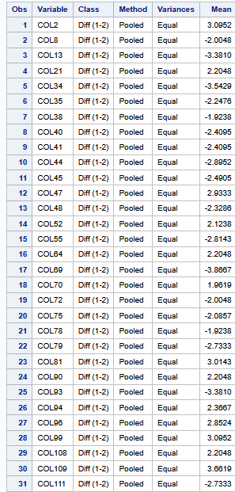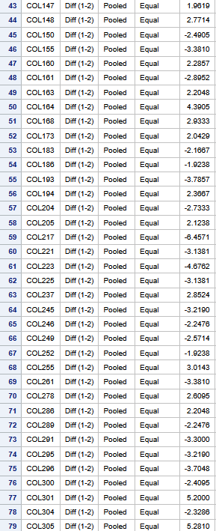

B: 